**Problem Set 7 (Due 4/15/2025 before class in stapled A4-sized paper)**

**Late homework will NOT be accepted, unless you have notified the course instructor 3 days BEFORE deadline.**

**Part I (60%)**

**文本, 信件

AI 生成的内容可能不正确。**

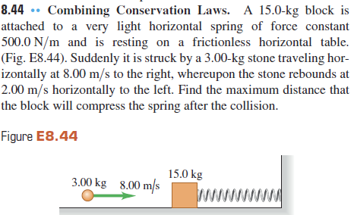

**Part II (40%)**

1. A 68.5-kg astronaut is doing a repair in space on the orbiting space station. She throws a 2.25-kg tool away from her at 3.2 m/s relative to the space station. With what speed and in what direction will she begin to move?
2. A 1300 kg race car is traveling at 80 m/s while a 15,000 kg truck is traveling at 20 m/s. Which has the greater momentum
3. When the momentum of an object doubles and its mass remains constant, how much does its kinetic energy change?
4. How much force is required to stop a 60 kg person traveling at 30 m/s during a time of 5 second?
5. Wayne hits a stationary 0.12-kg hockey puck with a force that lasts for 0.01 s and makes the puck shoot across the ice with a speed of 20.0 m/s, scoring a goal for the team. With what force did Wayne hit the puck?

For problems 6 and 7: A tennis ball traveling at 10.0 m/s is returned by Venus Williams. It leaves her racket with a speed of 36.0 m/s in the opposite direction from which it came.

1. What is the change in momentum of the tennis ball?
2. If the 0.060-kg ball is in contact with the racket for 0.020 s, with what average force has Venus hit the ball?
3. A 20 g ball of clay traveling east at 3.0 m/s collides with a 30 g ball of clay traveling north at 2.0 m/s. What are the speed and the direction of the resulting 50 g ball of clay?
4. A 2 kg mass is at (x, y)=(1 m, 2 m), and a 4 kg mass is at (x, y)=(5 m, 6 m). Calculate the center of mass.
5. A uniform rod of length 2 meters and mass 8 kg has one end at x=0 m and the other at x=2 m. Find the center of mass.